**Report Title:**

Testing and validation of the Dallas wet test fixture with python GUI

**Contributions:**

Testing, Isaiah Baker

Report preparation, Isaiah Baker

**Client:**

Profound Medical Inc, 2400 Skymark Ave #6, Mississauga, ON L4W 5K5, Canada

**Date:**

July 7th, 2022

**Executive Summary:**

The Dallas Wet Test Fixture system was found to provide highly repeatable measurements of the position of UA elements and the efficiency of the elements at those positions within about 1% when an element is tested back-to-back and 3% when a device is tested back-to-back. The efficiency results, when compared to the initial calibration of 6 selected devices, differ by approximately 5 percentage points on average. After a couple tests did not correctly fail devices that failed their initial calibration, the cause was determined to be an inaccurate power meter calibration and was since resolved. Upon retesting the system correctly fails the elements that failed initially. An additional test was done to compare the high and low frequency efficiency results of a UA at two different forward power levels, about 1 Watt and about 5.35 Watts. The resulting differences were small (typically under 2%), supporting the assumption that efficiency is not highly dependent on forward power.

Further testing is recommended to investigate any remaining differences and validate the system for production. First, it is recommended to validate the new software on existing hardware, which is scheduled for the week of July 18th. When the Dallas Wet Test Fixture hardware is deployed, any differences between the new and existing hardware can be investigated and, if they are determined to produce substantial differences in results, addressed.

In February 2022 8fold Manufacturing was contracted by Profound Medical to create a new graphical user interface for their existing and future Wet Test Fixture (WTF) systems. The goal was to transition from a closed-source LabView interface to a modular, easy-to-maintain, and well documented python application that can be improved and kept up to date by either 8fold or Profound in the future.

Several months after the project was contracted it was expanded to include the construction of an additional Wet Test Fixture system, using a combination of parts provided by Profound and parts purchased by 8Fold. The system includes 2 significant hardware changes in the interest of future proofness, durability, and reliability. These are the transition from a Precision Acoustics hydrophone to an Onda hydrophone, and the transition from a Parker VIX 250-IM Drive Motor controller system to a Galil 4123 motor controller system. Both are designed to be backwards-compatible with all existing hardware.

This testing is also being conducted with a different RF power amplifier than the one used by Profound, an NP Technologies NP-2940 amp with 42 dB gain and a 20dB attenuator attached. Both are impedance matched at 50 ohms and for the sake of this report the efficiency results with this amplifier are assumed to be comparable to those of the Profound WTF power amplifiers.

As of the time of this report, the project is nearing completion, and the software is reaching a state of maturity as it is tested, validated, and being iterated upon.

The goals of this report are as follows:

* Quantify the differences between the new and existing Wet Test Fixture systems
* Document the testing that was done to further investigate these differences
* Describe the hardware and software iterations that were made to address these differences
* Provide conclusions and recommendations for further testing and deployment of the new hardware and software.

When the hardware and software comprising the Dallas Wet Test Fixture system first reached a state where it was able to collect efficiency data reliably, the first testing objective was to compare its preliminary results to results from the existing WTF systems.

To assess the differences in results between this new wet test fixture and the existing wet test fixtures, a sample of 3 good UAs and 3 bad UAs were taken from stock. Their initial tests on existing wet test fixtures range from September 2019 to September 2021. Some were tested on WTF03 and some were tested on WTF04.

Each UA was tested with a script similar to the standard WTF test script version 1.2 with the only difference being voltage amplitudes adjusted for an NP Technologies NP-2940 amp with a 20dB attenuator attached. The find element voltage was increased from 50 mV to 500 mV due to the 10x attenuator, and the low frequency and high frequency efficiency test voltages were increased to 1500 mV and 1750 mV respectively to target 1 watt of forward power.

In these tests, efficiency was assumed to be independent of the forward power level. Approximately 1 watt forward was chosen because it is well within safe operating limits for the hardware and has appeared in example test data provided by Profound.

Note: After this phase of testing was completed, it became clear that this forward electrical power level was less than the forward electrical power level of the initial calibration. In a later section this will be investigated as a possible explanation for the differences in results.

**Results:**

Table Preliminary Comparison Test Results

|  |  |  |  |  |  |  |  |
| --- | --- | --- | --- | --- | --- | --- | --- |
|  |  | Efficiency (percent) | | | | | |
|  |  | Low Frequency | | | High Frequency | | |
|  | Element | Prev. WTF | WTF 4 | Diff (%) | Prev. WTF | WTF 4 | Diff (%) |
| GD0439 (Good) | 1 | 65.4 | 61 | 4.4 | 38.2 | 41 | 2.8 |
| 2 | 63.3 | 62 | 1.3 | 35.7 | 42 | 6.3 |
| 3 | 63.7 | 61 | 2.7 | 38.3 | 44 | 5.7 |
| 4 | 65.2 | 73 | 7.8 | 38.9 | 48 | 9.1 |
| 5 | 68 | 61 | 7.0 | 39.1 | 49 | 9.9 |
| 6 | 78.8 | 63 | 15.8 | 41.4 | 46 | 4.6 |
| 7 | 66.3 | 63 | 3.3 | 35.6 | 44 | 8.4 |
| 8 | 63.4 | 64 | 0.6 | 37 | 42 | 5.0 |
| 9 | 74.3 | 76 | 1.7 | 30.2 | 41 | 10.8 |
| 10 | 65.2 | 62 | 3.2 | 34.7 | 39 | 4.3 |
| GB0325 (Good) | 1 | 68.8 | 64 | 4.8 | 38.8 | 38 | 0.8 |
| 2 | 77.3 | 76 | 1.3 | 35 | 41 | 6.0 |
| 3 | 73.4 | 65 | 8.4 | 39 | 47 | 8.0 |
| 4 | 69.9 | 63 | 6.9 | 42.5 | 48 | 5.5 |
| 5 | 51.1 | 50 | 1.1 | 45 | 47 | 2.0 |
| 6 | 76.5 | 58 | 18.5 | 45.8 | 51 | 5.2 |
| 7 | 71.2 | 70 | 1.2 | 44.9 | 49 | 4.1 |
| 8 | 69.3 | 66 | 3.3 | 47.8 | 53 | 5.2 |
| 9 | 72.4 | 62 | 10.4 | 47.7 | 52 | 4.3 |
| 10 | 65.9 | 62 | 3.9 | 46.7 | 49 | 2.3 |
| FG0210 (Good) | 1 | 73.3 | 59 | 14.3 | 46 | 51 | 5.0 |
| 2 | 74.7 | 74 | 0.7 | 46.1 | 54 | 7.9 |
| 3 | 78.2 | 65 | 13.2 | 47.7 | 58 | 10.3 |
| 4 | 77.9 | 66 | 11.9 | 44.4 | 50 | 5.6 |
| 5 | 72 | 67 | 5.0 | 45.3 | 52 | 6.7 |
| 6 | 76.4 | 65 | 11.4 | 46.6 | 54 | 7.4 |
| 7 | 74.8 | 60 | 14.8 | 42.3 | 51 | 8.7 |
| 8 | 73.1 | 68 | 5.1 | 45.4 | 55 | 9.6 |
| 9 | 74.5 | 67 | 7.5 | 41 | 53 | 12.0 |
| 10 | 69.6 | 69 | 0.6 | 43.2 | 52 | 8.8 |
| HB0558 (Bad, DNF) | 1 | 44 | 47 | 3.0 | 17 | 38 | 21.0 |
|  |  |  |  |  |  |  |  |
| LC0014 (Bad) | 1 | 77.3 | 80 | 2.7 | 40.5 | 41 | 0.5 |
| 2 | 62.7 | 62 | 0.7 | 38.3 | 39 | 0.7 |
| 3 | 64.4 | 69 | 4.6 | 42.3 | 49 | 6.7 |
| 4 | 79.7 | 82 | 2.3 | 41 | 47 | 6.0 |
| 5 | 79.4 | 80 | 0.6 | 41.8 | 52 | 10.2 |
| 6 | 77.2 | 82 | 4.8 | 44.5 | 53 | 8.5 |
| 7 | 76.5 | 78 | 1.5 | 40.1 | 47 | 6.9 |
| 8 | 75.6 | 77 | 1.4 | 42.4 | 50 | 7.6 |
| 9 | 71.4 | 77 | 5.6 | 40.7 | 45 | 4.3 |
| 10 | 72.9 | 75 | 2.1 | 44.5 | 46 | 1.5 |
| HB0462 (Bad, DNF) | 1 | 49 | 56.8 | 7.8 | 22 | 26.5 | 4.5 |
| 2 | 51 | 56.6 | 5.6 | 26 | 26.5 | 0.5 |
| 3 | 42 | 53.1 | 11.1 | 21 | 26.5 | 5.5 |
|  | Mean: | 69.02 | 66.31 | 5.6 | 39.83 | 46.08 | 6.3 |
|  | Systematic error (%) | | | 2.72 |  |  | 6.25 |
|  | Average Difference (%) | | | 5.6 |  |  | 6.3 |

**Discussion**

The average percentage difference for low frequency efficiency was 5.6 percent, and the average percentage difference for high frequency efficiency measurements was 6.3 percent. Both of these fall well within the acceptance criteria of 20%, and in particular the low frequency results are likely within the margin of error of variability across years of storage and changing climate conditions, shipping et cetera.

The main discrepancy in these results that requires addressing is the systematic difference (difference between means) of 6.25% between the high frequency efficiency percent results, which is particularly concerning because that is an absolute percentage difference, when divided by the expected mean efficiency percent, the systematic error between 39.83% efficiency and 46.08% efficiency is 15.8 percent of the expected value.

Upon further investigation of the data from the initial testing it became clear that these UAs had their initial high frequency calibration done at between 5.3 watts and 5.5 watts forward electric power, compared to the 1 watt forward electric power that was used in this data set. This was an oversight due to the tests being done before comparison data was received. This observation lends itself to the hypothesis that the efficiency of the elements goes down at higher power levels. To test this hypothesis,

A follow up test will be done comparing the efficiency measurements of select elements at their high frequency with 1 watt forward electric power and comparing them to a comparable efficiency measurement at 5.35 watts forward electric power.

The elements that will be used for this follow up test will be element 1 of HB0558 and element 3 of HB0462. These elements (the ones whose percentage error is highlighted in red) were chosen because they are the elements that caused their UAs to fail their original WTF testing and were not considered failing by the Dallas wet test fixture.

In the failed element retest section, it will be determined whether these tests were given a false positive result because they were tested at a different power level than their initial calibration.

After the preliminary comparison of the results of the new and existing WTF systems, the next objective was to characterize the characteristics of the Dallas WTF system on its own.

As a control to demonstrate the noise floor of the system and its ability to detect the presence or absence of ultrasound radiation force, the UA was surrounded by a roll of paper within the tank in an attempt to dampen any detectable ultrasound.

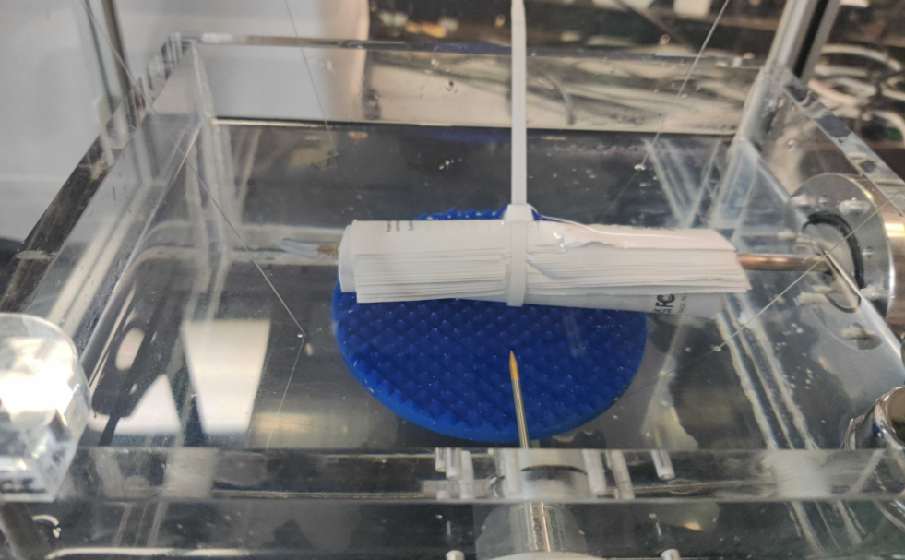

Figure Blocked UA

A find element sequence was done on element 5 of the UA, as well as low frequency and high frequency efficiency test sequences.

Figure 2 Find Element Theta Profile with UA blocked

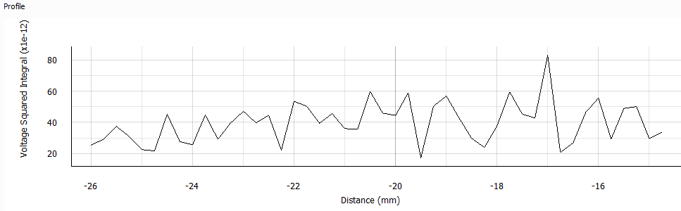

Figure 3 Find Element X Profile with UA blocked

As expected, the find element results were indistinguishable from random noise with the UA disconnected and showed no clear trend towards a maximum.

Figure 4 Measure Element Efficiency Data with UA blocked

Accordingly, the measure element efficiency data showed typical forward and reflected electrical power, and no detectable acoustic power, confirming the system’s ability to detect when a UA is absorbing electrical power but is producing less ultrasound than expected.

To measure the baseline measurement error of the system, one element of a good UA

(The 5th element of GD0439) was tested 10 times, including retraction and insertion. In each trial, the find element sequence was executed with 16 samples of averaging, and then the UA performed the measure element efficiency sequence at the X and R coordinate where the maximum voltage squared interval was observed.

Figure 5 Good UA Find Element Theta Profile

Figure 6 Good UA Find Element X Profile

Figure Good UA Efficiency Test

|  |  |  |  |  |
| --- | --- | --- | --- | --- |
|  | Single Element Repeatability Test Results | | | |
| X (mm) | Theta (deg) | LF Eff (%) | HF Eff (%) |
| 20.6 | -86.00 | 42.8 | 73.18 |
| 20.6 | -86.00 | 42.36 | 73.69 |
| 20.6 | -86.00 | 41.65 | 73.45 |
| 20.6 | -86.00 | 41.98 | 73.87 |
| 20.6 | -86.00 | 41.93 | 73.7 |
| 20.6 | -86.00 | 41.81 | 73.72 |
| 20.6 | -86.00 | 42.09 | 74.33 |
| 20.6 | -86.00 | 42.05 | 73.91 |
| 20.6 | -86.00 | 41.97 | 73.54 |
| 20.6 | -86.00 | 41.72 | 73.89 |
| Mean | 20.6 | -86.0 | 42.0 | 73.7 |
| STDEV (+/-) | 0.0 | 0.0 | 0.3 | 0.3 |
| 1/2 Step Size (+/-) | 0.2 | 0.2 | N/A | N/A |
| Accurate within | **0.2 mm** | **0.2 mm** | **0.30 %** | **0.30 %** |

Table 2 Single Element Repeatability Test Results

**Discussion:**

The find element results for both X and Theta revealed themselves to be exactly repeatable across all 10 trials with a step size of 0.4 mm and 0.4 degrees respectively. This is due to a high signal to noise ratio of the hydrophone measurements with averaging set to 16, and the positioning accuracy of the new Galil motor controller system. The only error in this case would be due to the finite step size. The actual position of the element may differ from the measured position by up to ½ of the step size, so 0.2 mm for X and 0.2 degrees for Theta.

The efficiency results were repeatable with a standard deviation of exactly 0.30 percentage points for both low frequency and high frequency efficiencies. This is small enough to detect subtle differences between UAs and differences between elements on the same UA.

To further investigate the repeatability of the system’s efficiency measurements, all 10 elements of 1 Good UA (GD0439) were tested, and then the UA was retracted and tested with the same settings a second time.

|  |  |  |  |  |  |  |  |  |  |
| --- | --- | --- | --- | --- | --- | --- | --- | --- | --- |
|  | **LF.Eff (%)** | | | **LF.Rfl (%)** | | | **LF.Pf(max) (W)** | | |
| **Element** | **Trial 1** | **Trial 2** | **diff (%)** | **Trial 1** | **Trial 2** | **diff (%)** | **Trial 1** | **Trial 2** | **diff (W)** |
| 1 | 61 | 61.7 | 0.7 | 2.8 | 2.8 | 0 | 6.7 | 6.7 | 0 |
| 2 | 72.1 | 73.1 | 1 | 0.9 | 1.3 | 0.4 | 5.5 | 5.5 | 0.0 |
| 3 | 74.3 | 75.4 | 1.1 | 0.3 | 0.2 | 0.1 | 5.4 | 5.3 | 0.1 |
| 4 | 75.2 | 75.9 | 0.7 | 0.1 | 0.7 | 0.6 | 5.3 | 5.3 | 0.0 |
| 5 | 71.3 | 70.8 | 0.5 | 1.4 | 1.2 | 0.2 | 5.7 | 5.7 | 0 |
| 6 | 63.4 | 62.5 | 0.9 | 4 | 4 | 0 | 6.6 | 6.7 | 0.1 |
| 7 | 61 | 61.1 | 0.1 | 7 | 7.5 | 0.5 | 7.1 | 7 | 0.1 |
| 8 | 69.8 | 70.2 | 0.4 | 0.4 | 0.3 | 0.1 | 5.7 | 5.7 | 0 |
| 9 | 62.9 | 62 | 0.9 | 4.8 | 4.4 | 0.4 | 6.6 | 6.8 | 0.2 |
| 10 | 62.1 | 62.5 | 0.4 | 2.4 | 2.7 | 0.3 | 6.6 | 6.6 | 0 |

Table 3 Single UA Low Frequency Repeatability Test Results

Table 4 Single UA High Frequency Repeatability Test Results

|  |  |  |  |  |  |  |  |  |  |
| --- | --- | --- | --- | --- | --- | --- | --- | --- | --- |
|  | **HF.Eff (%)** | | | **HF.Rfl (%)** | | | **HF.Pf(max) (W)** | | |
| **Element** | **Trial 1** | **Trial 2** | **diff (%)** | **Trial 1** | **Trial 2** | **diff (%)** | **Trial 1** | **Trial 2** | **diff (W)** |
| 1 | 39.5 | 39.5 | 0 | 0.3 | 0.3 | 0 | 5.1 | 5.1 | 0 |
| 2 | 38.5 | 38.7 | 0.2 | 0.4 | 0.4 | 0 | 5.2 | 5.2 | 0 |
| 3 | 42 | 42.1 | 0.1 | 0.1 | 0.1 | 0 | 4.8 | 4.7 | 0.1 |
| 4 | 40.9 | 40.8 | 0.1 | 0.3 | 0.3 | 0 | 4.9 | 4.9 | 0 |
| 5 | 41.7 | 41.7 | 0 | 0.8 | 0.8 | 0 | 4.8 | 4.8 | 0 |
| 6 | 43.7 | 43.5 | 0.2 | 0 | 0 | 0 | 4.6 | 4.6 | 0 |
| 7 | 40.6 | 40.5 | 0.1 | 1.7 | 1.7 | 0 | 5 | 5 | 0 |
| 8 | 41.4 | 41.3 | 0.1 | 0.1 | 0.1 | 0 | 4.8 | 4.8 | 0 |
| 9 | 38.4 | 38.3 | 0.1 | 0.9 | 0.9 | 0 | 5.3 | 5.3 | 0 |
| 10 | 37.1 | 36.9 | 0.2 | 0.7 | 0.7 | 0 | 5.4 | 5.5 | 0.1 |

**Discussion:**

In general, all of these measurements show themselves to be repeatable within 1% or less (with only 1 minor exception). It is clear from these results that high frequency results are much more repeatable than low frequency results (with the efficiency result being repeatable within 0.2%). Reflected power percent managed to be fully repeatable for all 10 elements within 0.1 watts of precision. High frequency measurements may be less sensitive to differences between tests. For example, tiny, hard to see bubbles in the UA heat shrink that may be present even if the operator makes an effort to remove them)

The initial testing of the 6 good UAs and 6 bad UAs found that every element of every device passed the test. This needs addressing because it is important that the acceptance criteria for devices is consistent across Wet Test Fixture systems.

Two changes were made in an attempt to make the efficiency results more accurate and similar to the existing WTF systems.

1. The power level of testing was increased from approximately 1W forward for both low and high frequencies to approximately 1.98 W forward for low Frequency and 5.38 Watts for High Frequency. This was done because the initial calibration of these UAs was performed at a power level closer to this (although it did vary slightly from UA to UA). Specifically, this is the power level for the failed UA HB0558.
2. The power meters were calibrated to match a more accurate Rhode and Shwartz benchtop unit. Specifically, the forward and reflected power meter measurements were scaled up by a factor of 1.127, which caused the measurements from the power meters to agree much more closely over their entire measurement range.

|  |  |  |  |  |  |  |  |
| --- | --- | --- | --- | --- | --- | --- | --- |
|  | | | **Prev System (%)** | | **New system (Preliminary)** | | |
| **UA** | **Element** | **Frequency** | **Eff (%)** | **Pass/Fail** | **Eff (%)** | **difference (%)** | **Pass/Fail** |
| HB0558 | 1 | Low | 44 | FAIL | 47 | 3.0 | PASS |
| High | 17 | 38 | 21.0 |
| HB0462 | 3 | Low | 42 | FAIL | 53.1 | 11.1 | PASS |
| High | 21 | 26.5 | 5.5 |
|  |  |  | Same Pass/Fail? | | **NO** | | |

Table 5 Preliminary Comparison Test Results for Failed Elements

|  |  |  |  |  |  |  |  |
| --- | --- | --- | --- | --- | --- | --- | --- |
|  | | | **Prev System (%)** | | **New system (After Iteration)** | | |
| **UA** | **Element** | **Frequency** | **Eff (%)** | **Pass/Fail** | **Eff (%)** | **difference (%)** | **Pass/Fail** |
| HB0558 | 1 | Low | 44 | FAIL | 29.8 | 14.2 | FAIIL |
| High | 17 | 26.2 | 9.2 |
| HB0462 | 3 | Low | 42 | FAIL | 21 | 21.0 | FAIL |
| High | 21 | 15.8 | 5.2 |
|  |  |  | Same Pass/Fail? | | **YES** | | |

Table 6 Test Results for Failed Elements after Iteration

**Discussion:**

The two iterations made to the system, although both clearly justified (either in the interest of eliminating differences with the initial test or by ensuring the measurements match another trusted measurement device) resulted in a mixture of results that matched more closely and those that matched less closely. Specifically, the high frequency measurements matched more closely and the low frequency measurements matched less closely. Across the board, the measured efficiency percentages decreased, which is likely because the forward power measurements from the initial testing were calibrated too low, resulting in overstated efficiencies.

The most positive development from these iterations was that the elements that failed their initial calibration now fail their test on the Dallas WTF system as well, demonstrating this system’s ability to distinguish between good and bad UAs.

The remaining discrepancies could be due to several factors including but not limited to:

* Changes to the UAs as a result of storage/transportation
* Differences between the power amplifiers
* Slight differences between the ultrasound absorbers and their placements
* Surface factors affecting the performance of the UA from test to test.

To narrow down these explanations, it is recommended to conduct further testing with the new software on existing WTF systems at Profound

The main discrepancy that was observed in the initial comparison test between the Dallas Wet test Fixture and the existing Wet Test Fixtures was that the average efficiency results at the UAs’ high frequencies were about 15% higher.

One hypothesis to explain this discrepancy was that it might have been due to the initial testing being conducted at a higher forward power level. For example, for UA GB0558, the initial testing was done at about 5.3 W forward power, but in the preliminary comparison test the forward power used was closer to 1 Watt. This may have caused systematic error in the high frequency results. If so, it would suggest that the high frequency efficiency of the element decreases as forward power increases.

To test this hypothesis, the same UA was tested at the original power level (1W) and a higher power level closely matching the initial calibration (1.98 W for LF, 5.35 W for HF).

Table 7 High and Low Power Comparison Test

|  |  |  |  |  |  |  |
| --- | --- | --- | --- | --- | --- | --- |
|  | LF eff (%) | | | HF eff (%) | | |
| Element | 1W Pf | 1.98 W Pf | diff (%) | 1W Pf | 5.35 W Pf | diff (%) |
| 1 | 60.6 | 57.8 | 2.8 | 34.6 | 32.8 | 1.8 |
| 2 | 61.3 | 60.3 | 1 | 32.6 | 34.1 | 1.5 |
| 3 | 59 | 57.4 | 1.6 | 43 | 41.3 | 1.7 |
| 4 | 55 | 54.6 | 0.4 | 43.4 | 41.2 | 2.2 |
| 5 | 42.2 | 41.8 | 0.4 | 43.5 | 41.2 | 2.3 |
| 6 | 66.2 | 65.9 | 0.3 | 43.9 | 42 | 1.9 |
| 7 | 57.1 | 55.5 | 1.6 | 43.6 | 41.1 | 2.5 |
| 8 | 64.9 | 64 | 0.9 | 47.9 | 46.1 | 1.8 |
| 9 | 58.6 | 56.5 | 2.1 | 44.8 | 43 | 1.8 |
| 10 | 56.8 | 55.2 | 1.6 | 44.6 | 42.5 | 2.1 |
| **Mean** | **58.17** | **56.9** | **1.27** | **42.19** | **40.53** | **1.96** |

**Discussion:**

The resulting difference in the efficiency results is small (under 2% on average) suggesting that there is not a very substantial dependency of the efficiency of a UA on the forward power used within this power range. It stands to reason that this is not the cause of the systematic error observed in the preliminary comparison test.

As mentioned in the previous section of this report, since the preliminary comparison test, the power meters were re-calibrated against a trusted reference devices (a calibrated, benchtop Rhode and Shwartz F/R power meter), and the difference between the calibrations was 12.7 percent. This seems a much more plausible explanation for why the high frequency efficiency was lower than expected in the first place.

The Dallas wet test fixture with python GUI has high frequency efficiency results that are repeatable within a tolerance of +/- 0.41 percent, low frequency efficiency results that are repeatable within a tolerance of +/- 0.71 percent, element X position measurements that are fully repeatable at a 0.4 mm resolution, and element Theta position measurements that are fully repeatable at a 0.4 mm resolution. The system also can be calibrated based on a reference power meter by changing its config file. After calibration, the system passes and fails elements in accordance with their initial WTF calibration.

Prior to calibration, the comparison between this system and the initial calibrations done on existing systems showed a difference of 5.6 percentage points at low frequencies and 6.3 percentage points at high frequencies. Both of these are well within the acceptance criteria of 20%. The latter was a systematic difference and was addressed by recalibrating the system. This also addressed the issue of elements passing their high frequency efficiency test when they should have failed.

An additional test was done to compare the high and low frequency efficiency results of a UA at two different forward power levels, about 1 Watt and about 5.35 Watts. The resulting differences were small (typically under 2%), supporting the assumption that efficiency is not highly dependent on forward power.

The remaining factors cannot be readily narrowed down without further on-site testing. The first phase of this will involve testing the same UA using existing software and using the new software on the same Wet Test Fixture equipment, to investigate if the difference is entirely on the hardware side.

When the new Wet Test fixture is brought to profound, any remaining differences due to different hardware can be investigated and resolved if they are found to be significant.